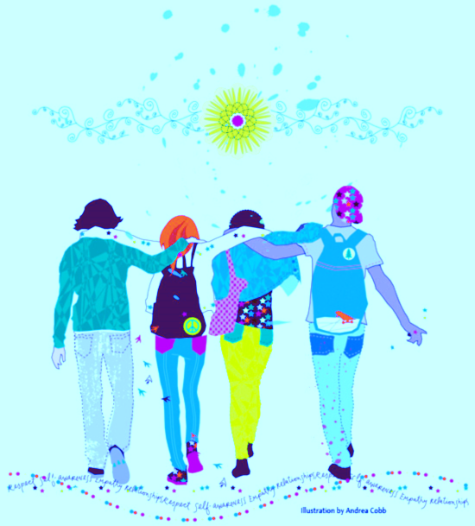
50 Things You Can Do Right Now to Support Students’ Mental Health and Wellness
- Learn student’s first names and greet them when you see them—high five, handshake, smile.
- Eat lunch with a student or group of students.
- Attend students’ extracurricular activities (sports, music programs, etc).
- Promote a growth mindset—praise effort and know-how.
- Volunteer as a club advisor or coach.
- Keep an optimistic focus on the future in conversations with students—‘you’re going to have so much fun in that class!’
- Include older students directly in IEP and/or behavior plan discussions.
- Have conversations with students about topics/activities that interest them.
- Play a game of cards, checkers, chess, Connect 4, etc with students.
- Ask about a class project that you know the student is working on.
- Remind colleagues about the 5:1 ratio (5 positives for every correction)—model this yourself.
- Encourage and model predictability and structure in school expectations.
- Send a ‘shout out’ or note to a student with a compliment.
- Call home and tell the parents/family something positive about a student.
- Keep an ‘inspiration file’—students keep pieces of work they are proud of in a folder, and can look back on them when they are having a rough day.
- Demonstrate/model gratitude—write down 3 things you are grateful for and post for students to see (encourage them to do the same).
- Put a variety of post it notes on/outside your door, with positive statements/affirmations for students to ‘take what they need’ for the day.
- Share your own interests with students—engage in common interests (build a model, doodle/color, etc).
- State what you observe—‘you look like you’re feeling sad today’—then offer the option of talking about it—model noticing how people are feeling and how to be supportive.
- Have a prize/incentive box available for when students meet a goal/achievement.
- Offer to be an incentive/reward for students on plans—be someone they can eat lunch with, play a game with, spend time with.
- Send regular (weekly, monthly) emails to staff highlighting strategies to support students with various needs (ADHD, anxiety, etc).
- Offer to teach a lesson (or consult) on social skills, mindfulness, managing big feelings, etc in a classroom.
- Teach staff a single, age appropriate coping skill at each staff meeting for them to share with their class.
- Have a ‘School Psychologist Question Box’--students can put in a request to talk with you.
- Work collaboratively with school counselors or social workers, and school nurses.
- Celebrate Mental Health Awareness Month (May) (many ideas online).
- Offer to run a book study on a mental health or SEL topic within your building or district.
- Have a poster with positive facts about a student and a ballot box for others to try to guess who this amazing student of the week might be—answers posted on Thursdays or Fridays.
- Leave your office door open—be available to students, staff, and parents.
- Have snacks available for hungry students.
- Use students’ chosen names or pronoun preferences (when safe to do so).
- Offer to be a Check In/Check Out person or mentor for a student.
- Provide staff with easily implementable ideas to support SEL in their classrooms—offer to model any strategies they are interested in.
- Be visible in the hallways—notice positive student behaviors—greet students and parents.
- Help parents and students find the supports they may need outside of school—collaborate with outside providers for student success in school.
- Offer to co-lead a group with the school counselor.
- Offer to take a social skills group for the special ed teacher.
- Provide information regarding ACEs, resilience, and trauma informed practice to your building staff—so they can support students in crisis.
- Have a ready stack of your schools’ ‘currency’ (Eagle Feathers, Tiger Paws, etc) and hand them out when you see students engaging in prosocial behaviors/expected behaviors.
- Do a ‘confidence challenge’—have students write down 10 things they like about themselves and when they show it to you they get a ‘reward’ (snack, small prize, etc)—they don’t have to let you read it, just show you that they did it (although many students would love to share it with you ).
- Put up a question of the day or week on your door and encourage students to come chat with you and answer the question—great conversation starter.
- Know students’ birthdays—give them a note or a card or simply tell them Happy Birthday when you see them.
- Offer to be a ‘break’ or ‘calm down’ space for a student when needed.
- Offer to go for a walk, take a break, walk the track, etc with a troubled student.
- Have an emotions or Zones of Regulation visual on your door—encourage students to choose how they are feeling or what zone they are in.
- Create a social detective scavenger hunt—have students find examples of prosocial or expected behaviors (per a scavenger hunt list of behaviors) with winners (make everyone a winner).
- Be visible at recess or lunch—allow students to engage with you in play or conversation.
- Arrange for a student to have a special job with you (delivering notes, taking something to a teacher, etc).
- Share with your administrators and staff all the skills/domains of practice that school psychologists are trained in, especially regarding social/emotional learning and development—ask how you can be of help.

