NASP Professional Practice Model 10 Domains of Practice in Brief*

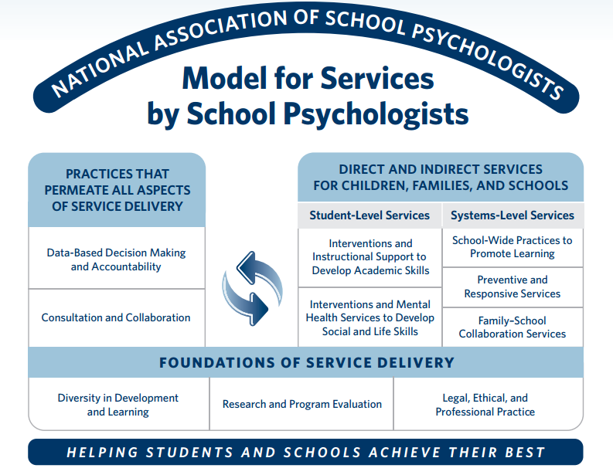

Practices That Permeate All Aspects of Service Delivery
- Domain 1: Data-Based Decision Making and Accountability
School psychologists have knowledge of varied models and methods of assessment and data collection for identifying strengths and needs, developing effective services and programs, and measuring progress and outcomes.
- Domain 2: Consultation and Collaboration
School psychologists have knowledge of varied models and strategies of consultation, collaboration, and communication applicable to individuals, families, groups, and systems and methods to promote effective implementation of services.

Direct and Indirect Services for Children, Families, and Schools

Student-Level Services
- Domain 3: Interventions and Instructional Support to Develop Academic Skills
School psychologists have knowledge of biological, cultural, and social influences on academic skills; human learning, cognitive, and developmental processes; and evidence-based curricula and instructional strategies.
- Domain 4: Interventions and Mental Health Services to Develop Social and Life Skills
School psychologists have knowledge of biological, cultural, developmental, and social influences on behavior and mental health, behavioral and emotional impacts on learning and life skills, and evidence-based strategies to promote social–emotional functioning and mental health.

Systems-Level Services
- Domain 5: School-Wide Practices to Promote Learning
School psychologists have knowledge of school and systems structure, organization, and theory; general and special education; technology resources; and evidence-based school practices that promote learning and mental health.
- Domain 6: Preventive and Responsive Services
School psychologists have knowledge of principles and research related to resilience and risk factors in learning and mental health, services in schools and communities to support multitiered prevention, and evidence-based strategies for effective crisis response.
- Domain 7: Family–School Collaboration Services
School psychologists have knowledge of principles and research related to family systems, strengths, needs, and culture; evidence-based strategies to support family influences on children’s learning and mental health; and strategies to develop collaboration between families and schools.

Foundations of School Psychological Service Delivery
- Domain 8: Diversity in Development and Learning
School psychologists have knowledge of individual differences, abilities, disabilities, and other diverse student characteristics; principles and research related to diversity factors for children, families, and schools, including factors related to culture, context, and individual and role difference; and evidence-based strategies to enhance services and address potential influences related to diversity.
- Domain 9: Research and Program Evaluation
School psychologists have knowledge of research design, statistics, measurement, varied data collection and analysis techniques, and program evaluation sufficient for understanding research and interpreting data in applied settings.
- Domain 10: Legal, Ethical, and Professional Practice
School psychologists have knowledge of the history and foundations of school psychology; multiple service models and methods; ethical, legal, and professional standards; and other factors related to professional identity and effective practice as school psychologists.

